BRAIN TUMOR IMAGE CLASSIFICATION USING IBM WATSON STUDIO

Aravind G 18BCE1190

Surya Srinivasan 18BCE1055

R A Keerthan 18BCE1208

Anahitaa R 18BCE1325

Anish Subramanian 18BLC1055

**PROBLEM STATEMENT**

The process of detection of tumors from MRI images of a brain is one of the highly focused areas in the community of medical science as MRI is noninvasive imaging. Radiologists are specialists who deal with detection and segmentation of brain tumors from MRI scans in their day-to-day lives, but it is possible to exhaust these specialists by burdening them with a surfeit of scans to analyse-- due to a plethora of reasons. This would not only cause a delay in analyses, but also cause them to flag, thereby increasing the chances of errors in diagnosis as a result of over-work and fatigue.

**SOLUTION**

The solution offered for this problem statement is the development of an image classification application, which analyzes the input MRI scans and accurately determines the presence of a tumor . Convolutional neural networks (CNN) implemented using necessary python libraries on IBM Watson Studio and Jupyter Notebook can be used to develop the model required to classify MRI images. Flask is used to integrate the deep learning model with a web user interface.

**LITERATURE SURVEY**

*Hybrid Tolerance Rough Set–Firefly based supervised feature selection for MRI brain tumor image classification.*

https://www.sciencedirect.com/science/article/abs/pii/S1568494616301235

The probability of survival can be enhanced if the tumor is detected at its premature stage. The intention of the feature-selection approach is to select a small subset of features which minimizes redundancy and maximizes relevance to the target such as the class labels in classification. Thus, the machine learning model receives a brief organization with high predictive accuracy using the selected prominent features. Therefore, currently, feature selection plays a significant role in machine learning and knowledge discovery. A novel hybrid supervised feature selection algorithm, called TRSFFQR (Tolerance Rough Set Firefly based Quick Reduct), is developed and applied for MRI brain images. The hybrid intelligent system aims to exploit the benefits of the basic models and at the same time, moderate their limitations. Different categories of features are extracted from the segmented MRI images, i.e., shape, intensity and texture based features.

*MR Image Classification Using Adaboost for Brain Tumor Type*

https://ieeexplore.ieee.org/abstract/document/7976880

Medical imaging techniques are actively developing fields in engineering. Magnetic Resonance imaging (MRI) is one of those reliable imaging techniques on which medical diagnosis is based upon. Manual inspection of those images is a tedious job as the amount of data and minute details are hard to recognize by the human. For this, automating those techniques are very crucial. In this paper, we are proposing a method which can be utilized to make tumor detection easier. The MRI deals with the complicated problem of brain tumor detection. Due to its complexity and variance, getting better accuracy is a challenge. Using Adaboost machine learning algorithm we can improve over accuracy issues. The proposed system consists of three parts such as PreIn medical diagnostic application, early defect detection is a crucial task as it provides critical insight into diagnosis. Medical imaging techniques are actively developing fields in engineering. Magnetic Resonance imaging (MRI) is one of those reliable imaging techniques on which medical diagnosis is based upon. Manual inspection of those images is a tedious job as the amount of data and minute details are hard to recognize by the human.

*A review on brain tumor segmentation of MRI images*

<https://www.sciencedirect.com/science/article/abs/pii/S0730725X19300347>

This paper presents an exhaustive study of several pre-existing methods of brain tumor detection and segmentation. The profound analysis through different evaluation parameters among state-of-the-art methods helps us readers and medical professionals not only set the new directions to develop the scope of research but also assists in accurate diagnosis of the tumor. Finally, reviewing different methods, it has been observed that the combination of CRF with FCNN and CRF with DeepMedic or Ensemble are most effective towards fulfilling the requirements of detection and segmentation of brain tumors.

**EXPERIMENTAL INVESTIGATIONS**

From our development of the project, we came to know that MRI images of Brain with tumors present have a higher contrast between the features in the images.

Using this each image was resized to 256 x 256 pixels and Convolution2D followed by a Maxpooling2D layer to form a feature map that contains the most prominent features of the images.

The output layer of the model uses sigmoid function as we only have 2 mutual classes, which is Tumor Present or not present, and in accordance to this loss is measured using binary cross entropy.

**HARDWARE AND SOFTWARE SPECIFICATIONS**

Windows OS (preferably), Anaconda and IBM Watson Studio are the required software. IBM Watson studio can also be accessed using a browser. Relevant python libraries such as tensorflow, keras, ibm_watson_machine_learning and opencv2 are some basic libraries necessary to work on this project. A system with 8GB RAM and a processor with i5 core and above (7th generation +) would satisfy the requirements for building deep-learning models.

**FLOWCHART**

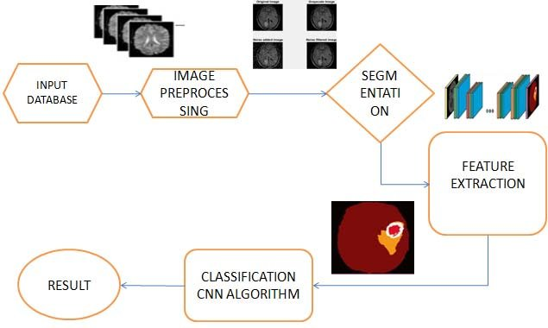

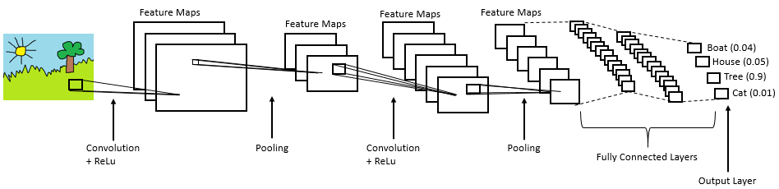

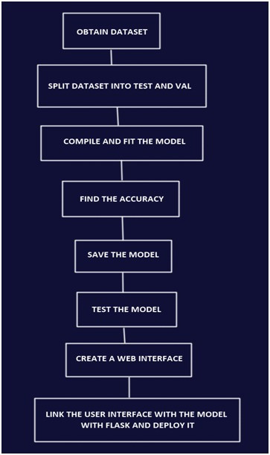

**CONCLUSION**

The model developed shows promising results with a relatively high accuracy--thereby making it appropriate to deem the model as extremely efficient--and the user-friendly interface only makes it easy for users to understand and work with.

**FUTURE SCOPE**

Some of the challenges faced in working with AI especially in time and result-sensitive domains such as medicine include: slight inaccuracies, incorrect analysis when presented with an input completely different from that encountered in the training set.

The first inhibiting factor is the access to large high quality labelled datasets for training.A technique called augmentation could be able to help solve that problem. Using augmentation, scientists are able to double, triple, or even quadruple datasets by modifying the available images in a way that new images are created, which still show the same characteristics, but are slightly different and, therefore, seen as “new training material” by the neural network

The most successful deep learning models are currently trained on simple 2D pictures. CT and MRI images are usually 3D, adding, literally, an extra dimension to the problem. Conventional x-ray images may be 2D, however, due to their projected character, current deep learning models are not adjusted to these either. Experience needs to be gained with applying deep learning to these types of images.

Finally, the non-standardized acquisition of images is one of the biggest challenges in medical image processing. The more variety there is in the data, the larger the dataset needs to be to ensure the deep learning network results in a robust algorithm. A method to tackle this barrier is to apply transfer learning, which is a pre-processing technique aimed to overcome scanner and acquisition specifics.

**BIBLIOGRAPHY**

https://towardsdatascience.com/building-a-convolutional-neural-network-cnn-in-keras-329fbbadc5f5

https://smartinternz.com/

https://ieeexplore.ieee.org/abstract/document/7976880

https://www.sciencedirect.com/science/article/abs/pii/S1568494616301235

<https://developer.ibm.com/patterns/image-classification-using-cnn-in-keras/>

<https://www.sciencedirect.com/science/article/abs/pii/S0730725X19300347>

https://ieeexplore.ieee.org/abstract/document/7976880

https://www.sciencedirect.com/science/article/abs/pii/S1568494616301235